Nithin S
221IT085

IT254 Lab Assignment - 1

Q1 ) Write an HTML program to display hello world

CODE

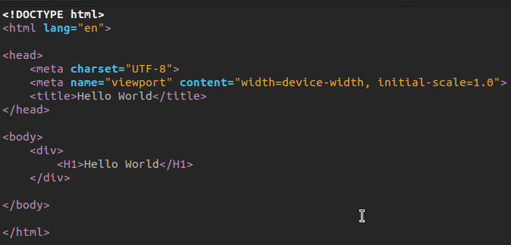

OUTPUT

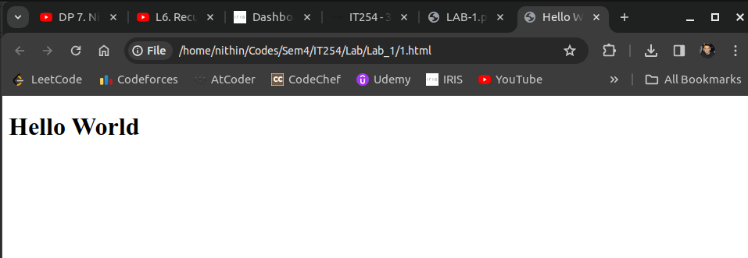

Q2 ) Write a program to create a webpage to print values 1 to 5

CODE

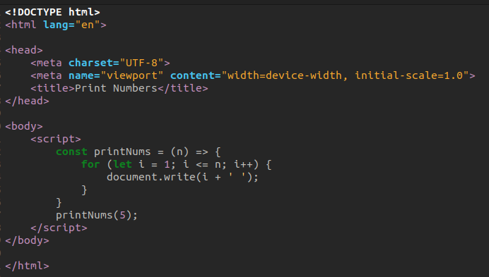
OUTPUT

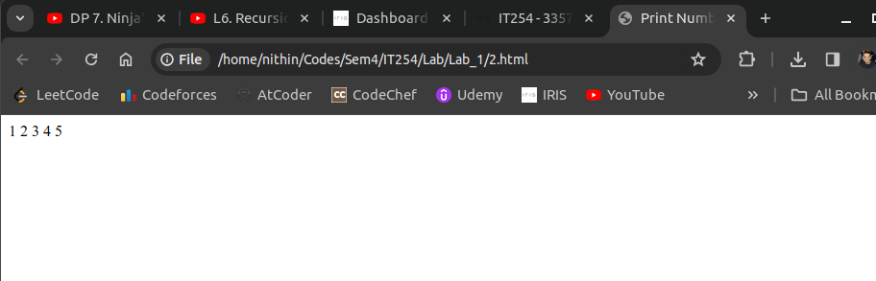

Q3 ) Write a program to create a webpage to print your city name in red color.

CODE

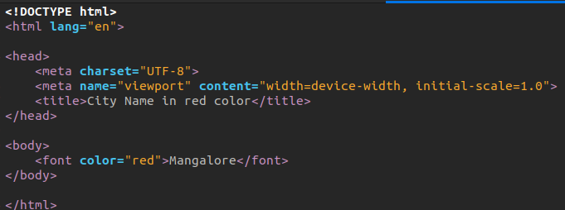

OUTPUT

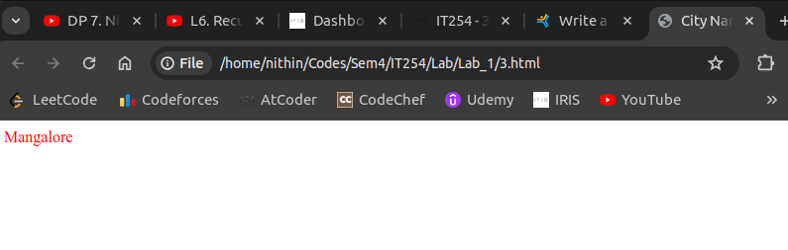
Q4) Write a program to print a paragraph with different font and color..

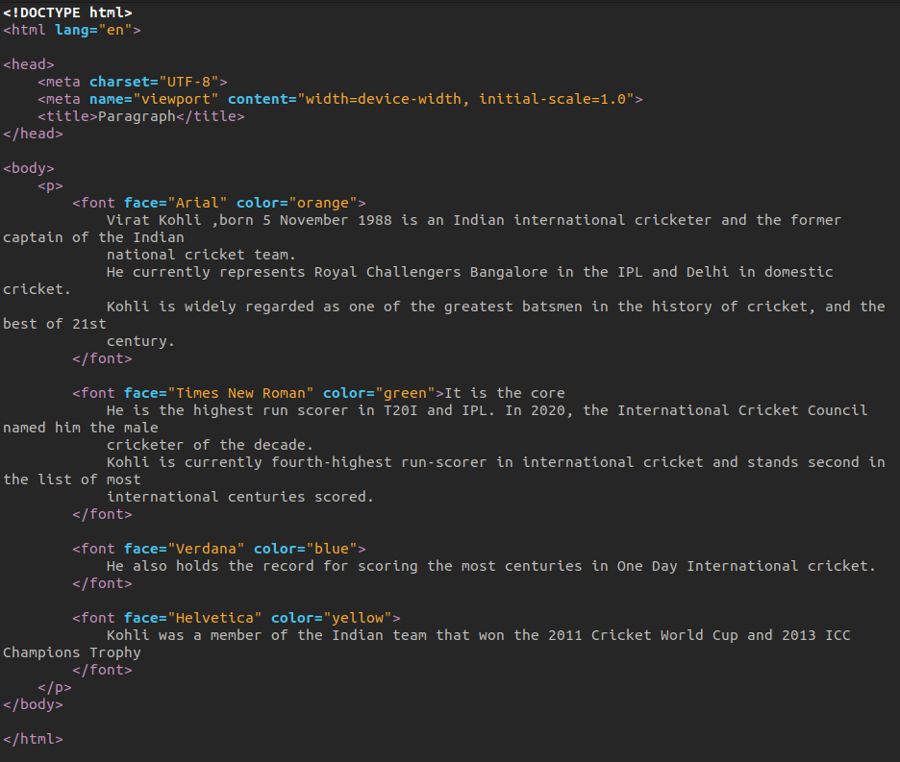
CODE

OUTPUT

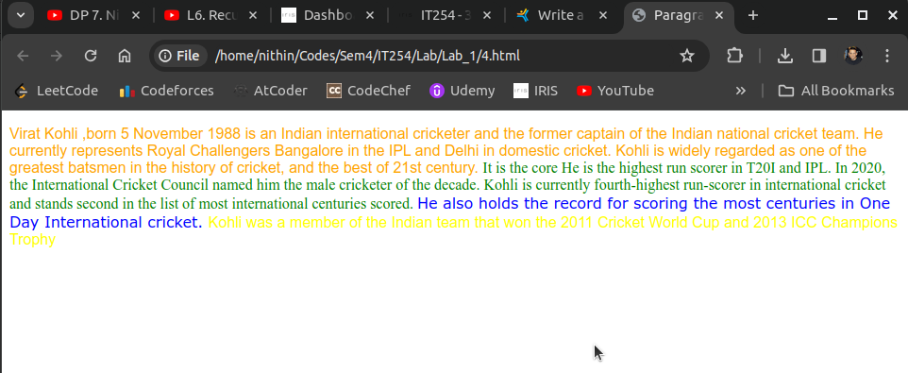

Q5) Write a JavaScript to design a simple calculator to perform the following operations: sum, product, difference and quotient

CODE

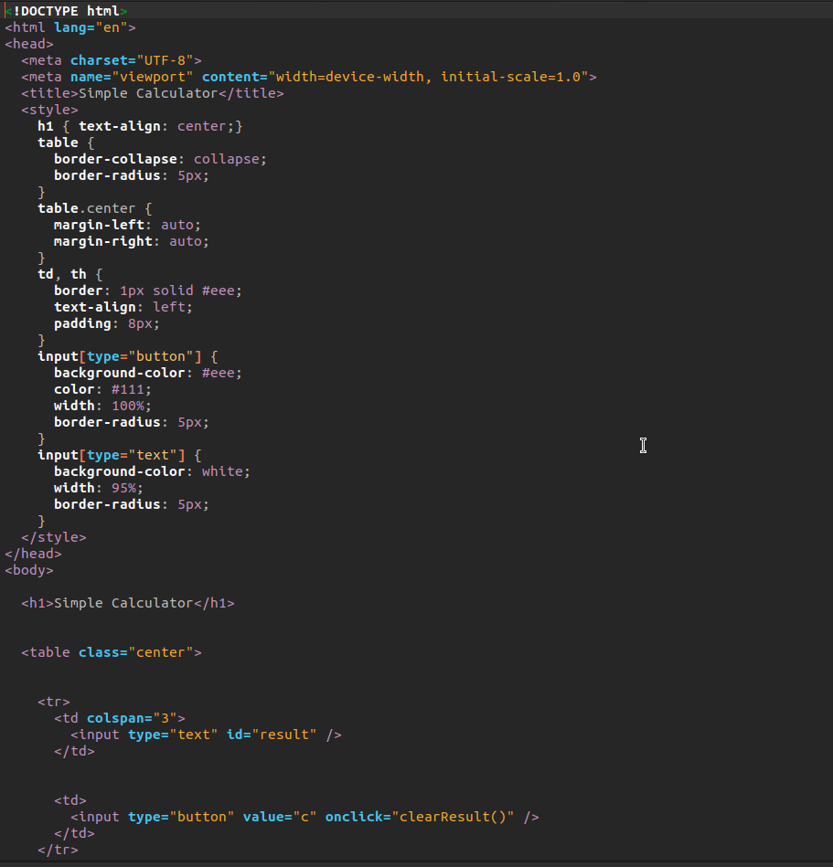

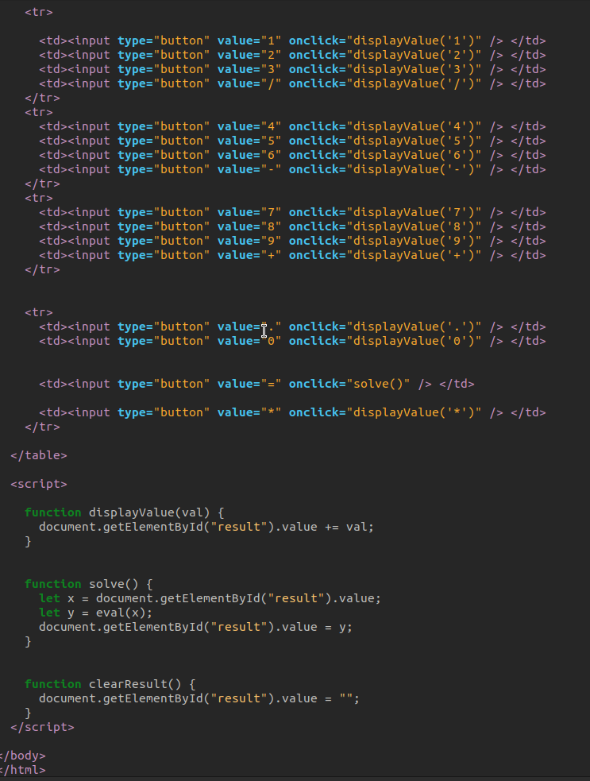

OUTPUT

